**MATERI 2: Telling People’s Jobs and Professions II**

**Kalimat Verbal**

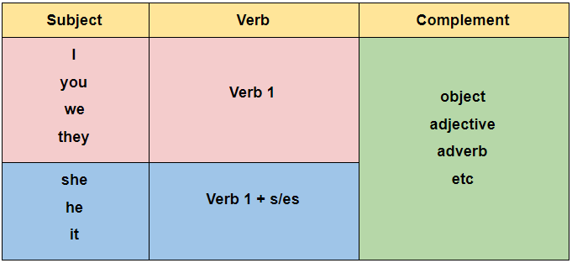

**Examples:**

* *They perform operations on their patients*
* *She teaches mathematics in junior high school*
* *He plants and grows rice*

**Kalimat Nominal**

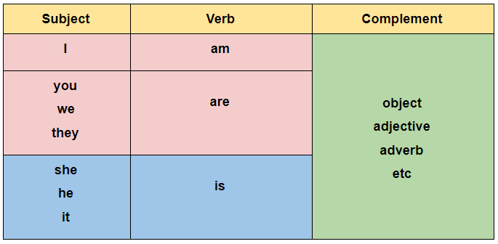

**Examples:**

* *She is a surgeon*
* *He is a teacher*
* *My father is a farmer*

Contoh:



My mother is a farmer.

She plants and grows rice.



My father and his friend are surgeons.

They perform operations on their patients.

Note: Ketika siswa mengklik bagian tulisan ataupun gambar, akan muncul audio berdasarkan kalimat yang sudah ditulis.